Partint de l’adreça 192.168.0.0/16 es demana que feu en grups de 4, col·laborativament, un diagrama general de la xarxa de classe, de forma que a cada fila hi hagi un router. A cada router hi connectareu:

- Dos PC de la mateixa fila
J18 – FastEthernet 0/0
j16 – FastEthernet 0/1

- Els dos routers de les files contigües (la del davant i la del darrera). En cas que sigui la primera o última fila, s’hi connectarà el router de la fila de l’altra banda del passadís (de l’esquerra o de la dreta)

Heu de proposar adreces de xarxa per a totes les xarxes necessàries, fent un aprofitament màxim de les adreces, però tenint en compte que a cada fila hi podrien haver fins a 100 ordinadors.

Un cop revisat per part del professor i assignades les adreces de xarxa, configureu els routers, incloent el DHCP.

Entregueu:
- El diagrama general de la xarxa de classe
- Un diagrama detallat de la xarxa de la vostra fila d’ordinadors
- El llistat de comandes que heu utilitzat al router

- El llistat de comandes que heu utilitzat per comprovar que la xarxa estava ben configurada
Instal·lar Putty
Buscar amb dmesg el dispositiu serial ttyUSB0
[ 777.216590] usb 2-1.4: Product: USB-Serial Controller
[ 777.216592] usb 2-1.4: Manufacturer: Prolific Technology Inc.
[ 777.217082] pl2303 2-1.4:1.0: pl2303 converter detected
[ 777.218762] usb 2-1.4: pl2303 converter now attached to ttyUSB0
Hem de canviar els permisos de ttyUSB0 y amb chmod canviar-ho amb els permisos o+rw.
Obrim el putty
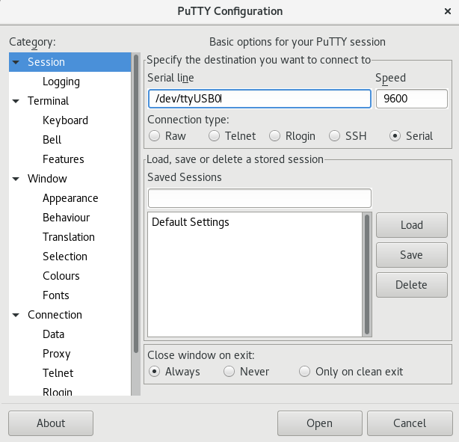

MixAritos>enable
Password: clase
MixAritos#
MixAritos#configure terminal
J18 (FastEthernet 0/0)
MixAritos#configure terminal
Enter configuration commands, one per line. End with CNTL/Z.
MixAritos(config)#interface FastEthernet 0/0
MixAritos(config-if)#ip address 192.168.4.1 255.255.255.128
MixAritos(config-if)#no shutdown
MixAritos(config-if)#
*Jan 1 00:40:59.931: %LINEPROTO-5-UPDOWN: Line protocol on Interface FastEthernet0/0, changed state to up
*Jan 1 00:41:01.235: %LINK-3-UPDOWN: Interface FastEthernet0/0, changed state to up
J16 (FastEthernet 0/1)
MixAritos#configure terminal
Enter configuration commands, one per line. End with CNTL/Z.
MixAritos(config)#interface FastEthernet 0/1
MixAritos(config-if)#ip address 192.168.4.129 255.255.255.128
MixAritos(config-if)#no shutdown
MixAritos(config-if)#
*Jan 1 00:50:21.883: %LINK-3-UPDOWN: Interface FastEthernet0/1, changed state to up
*Jan 1 00:50:22.883: %LINEPROTO-5-UPDOWN: Line protocol on Interface FastEthernet0/1, changed state to up
*Jan 1 00:50:24.307: %LINK-3-UPDOWN: Interface FastEthernet0/1, changed state to up
MixAritos(config-if)#
DHCP J18 (FastEthernet 0/0)
MixAritos>enable
MixAritos#configure terminal
Enter configuration commands, one per line. End with CNTL/Z.
MixAritos(config)#ip dhcp pool POOL1
MixAritos(dhcp-config)#network 192.168.4.0 255.255.255.128
MixAritos(dhcp-config)#default-router 192.168.4.1
MixAritos(dhcp-config)#ip dhcp excluded-address 192.168.4.1
MixAritos(config)#exit
MixAritos#
*Jan 1 00:53:08.239: %SYS-5-CONFIG_I: Configured from console by console
MixAritos#
J18
[root@j18 ~]# /etc/init.d/network restart
Restarting network (via systemctl):
[ OK ]

DHCP J16 (FastEthernet 0/1)
MixAritos>enable
MixAritos#configure terminal
Enter configuration commands, one per line. End with CNTL/Z.
MixAritos(config)#ip dhcp pool POOL2
MixAritos(dhcp-config)#network 192.168.4.128 255.255.255.128
MixAritos(dhcp-config)#default-router 192.168.4.129
MixAritos(dhcp-config)#ip dhcp excluded-address 192.168.4.129
MixAritos(config)#exit
MixAritos#
*Jan 1 00:59:03.415: %SYS-5-CONFIG_I: Configured from console by console
MixAritos#
J16
[root@j16 ~]# /etc/init.d/network restart
Restarting network (via systemctl):
[ OK ]
Router R18x05 guardar a l'startup-config
MixAritos#copy running-config startup-config
Destination filename [startup-config]?
Building configuration...
[OK]
MixAritos#

Router R18x05 (Serial 0/0/1)
MixAritos#configure terminal
Enter configuration commands, one per line. End with CNTL/Z.
MixAritos(config)#interface Serial 0/0/1
MixAritos(config-if)#ip address 192.168.250.21 255.255.255.252
MixAritos(config-if)#no shutdown
MixAritos(config-if)#
*Jan 1 01:17:12.003: %LINK-3-UPDOWN: Interface Serial0/0/1, changed state to up
*Jan 1 01:17:15.003: %LINEPROTO-5-UPDOWN: Line protocol on Interface Serial0/0/1, changed state to up
MixAritos(config-if)#exit
Router R18x05 (Serial 0/0/0)
MixAritos#configure terminal
Enter configuration commands, one per line. End with CNTL/Z.
MixAritos(config)#interface Serial 0/0/0
MixAritos(config-if)#ip address 192.168.250.14 255.255.255.252
MixAritos(config-if)#no shutdown
*Jan 1 01:18:30.015: %LINK-3-UPDOWN: Interface Serial0/0/0, changed state to d MixAritos(config-if)#exit

Routing Serial 0/0/0 i Serial 0/0/1
MixAritos(config)# ip route 192.168.5.0 255.255.255.128 se0/0/1
MixAritos(config)# ip route 192.168.3.0 255.255.255.128 se0/0/1
MixAritos(config)# ip route 192.168.1.0 255.255.255.128 se0/0/1
MixAritos(config)# ip route 192.168.0.0 255.255.255.128 se0/0/0
MixAritos(config)# ip route 192.168.2.0 255.255.255.128 se0/0/0
PING A LES DIFERENTS XARXES
